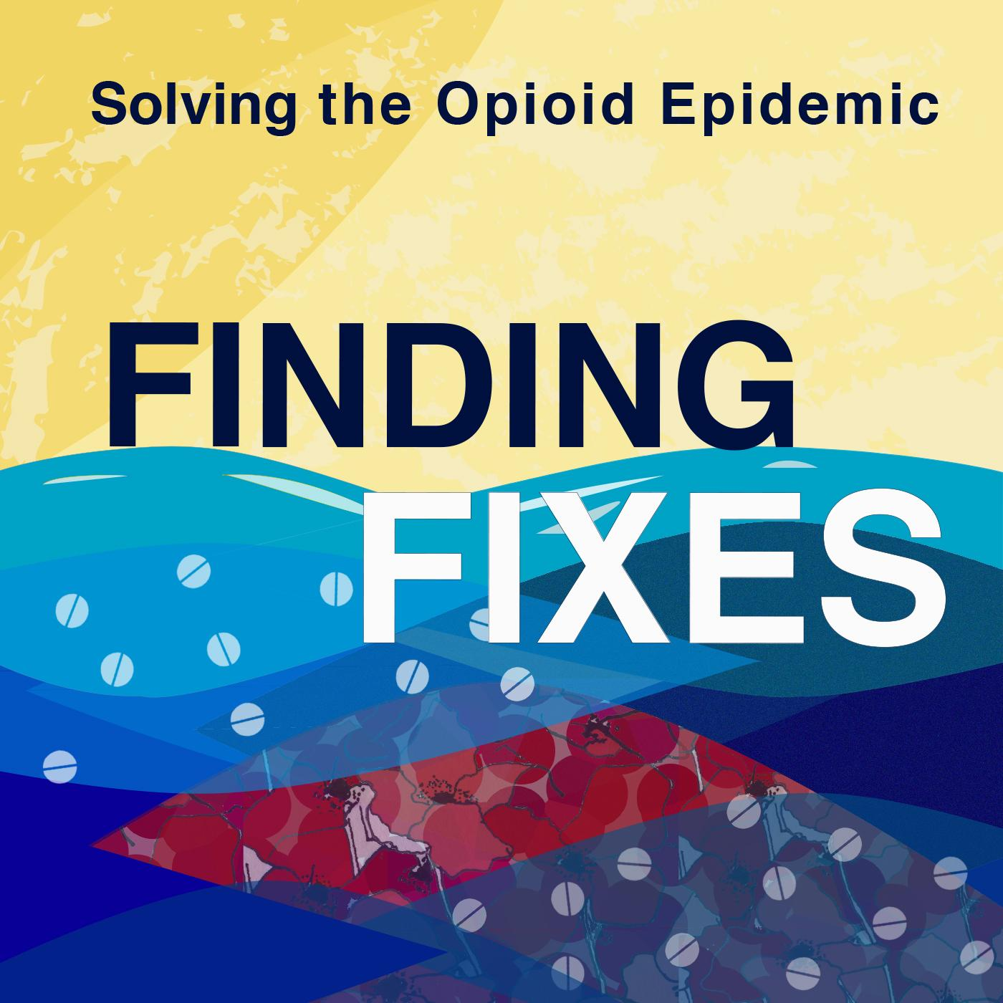

Key Statistics About the Opioid Epidemic*
____________________________________________

Opioids are a class of drugs that include heroin, fentanyl, and pain relievers such as oxycodone, hydrocodone, codeine, and morphine.

- More than 130 people die in the U.S. each day after overdosing on opioids.

- Approximately 80% of people who use heroin abused prescription drugs first.

- From July 2016 to Sept. 2017, the most recent data available, opioid overdoses increased 30% in 52 areas and 45 states – with the Midwest hit especially hard and seeing a 70% increase in overdoses over the same time period.

- In 2017, an estimated 1.7 million Americans suffered from substance abuse disorders related to prescription opioids.

- Approximately 21-29% of patients who are prescribed prescription opioids misuse them, and between 8-12% develop an opioid use disorder.

- According to the U.S. Department of Health and Human Services, 3.6% of children ages 12-17 reported misusing prescription opioids in 2016. That percentage doubled for young adults ages 18-25.

- Of the more than 70,000 drug overdose deaths in 2017, the most recent data available, approximately 68% of those deaths involved opioids, according to the Centers for Disease Control and Prevention (CDC).

- The CDC estimates that prescription opioid misuse in the U.S. costs taxpayers $78.5 billion a year which includes lost productivity, addiction treatment, and healthcare.

*Unless otherwise noted, all statistics provided by the National Institute on Drug Abuse.

