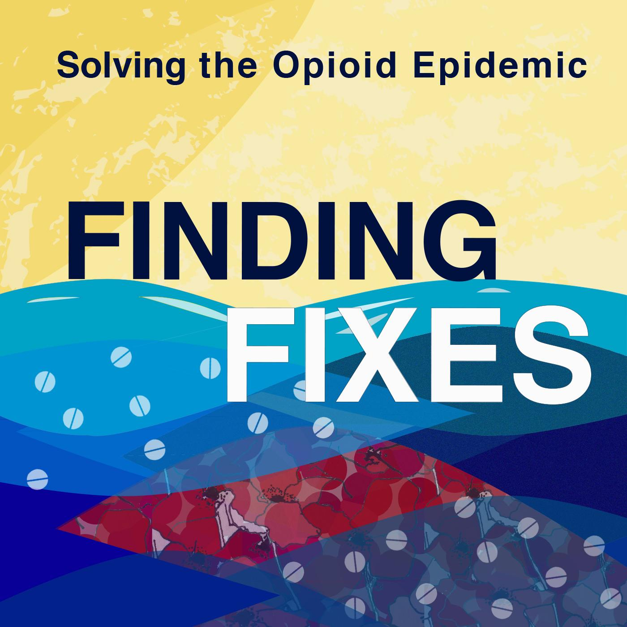

What Listeners Are Saying About Finding Fixes
____________________________________________

BENEFICIAL TO THOSE “ON THE GROUND”: "Thank you so much for featuring the challenges, barriers, and stigmas associated with opioids and recovery. Listening to the personal stories/journey of addiction and recovery was so beneficial to my work.” – Hospital professional in Washington state

TRULY AN AMAZING RESOURCE: “Informative, gives you different perspectives and helps people understand the complexities of addiction. As someone who has a loved one who suffers from addiction, this gives me hope for them. This is truly an amazing resource for those of us who just want to understand how to help instead of treating addicts as outcasts.” – Listener Kayla Cruz

HONEST, RESPECTFUL, AND REAL: “Wow … Your attention to detail is impressive. Homelessness, addiction, and treatment is complex, and it is clear you have taken the time to learn about the complexities. Your passion about the subject is evident, and, most importantly, your depiction of each individual is honest, respectful, and real. I will be working hard to encourage everyone I know to take the time to listen to your work.” – County behavioral health supervisor in Washington state

HOPEFUL AND INFORMATIVE: “If you think there is nothing anyone can do to stop the opioid epidemic, this podcast is for you. Restores hope and humanity to a landscape that sorely needs it.” – Medea1980, iTunes

SO IMPORTANT: “The journalism in this podcast is top-notch. These stories come at a time when the opioid crisis in this country is devastating families all over America ... The solution to this crisis will require sharing information about addiction and life-saving drugs (which this podcast does very well), and will require thinking outside the box in some of the ways this podcast highlights.” – Phirelyte, iTunes

IN DEPTH, REALISTIC, HOPEFUL: “They clearly took the time to get to know the people they're reporting on. Reminds me a bit of NPR's Embedded, but with a focus on solutions.” – Rob*Smith, iTunes

INFORMATIVE: “... This podcast is sad, but hopeful ... I recommend this to anyone who is affected directly or indirectly (we are all affected indirectly) by addiction. Good job to the Finding Fixes peeps – I look forward to season 2.” – Seattle500, iTunes

INFORMATIVE AND INTERESTING: “I feel like opiate addiction is on the rise. Needles in the park, more slouched figures with vacant stares – these are more common. The hosts focus on solutions with great storytelling … eager to hear more.” – Sad Tweeter, iTunes

