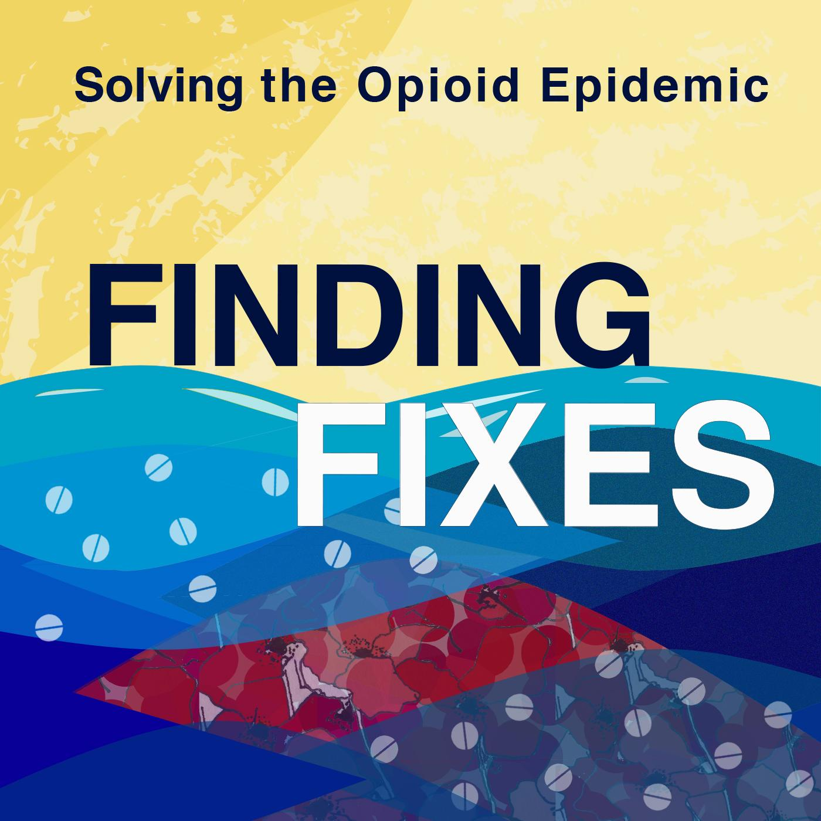

ABOUT FINDING FIXES
www.findingfixes.com
____________________________________________

ABOUT THE PODCAST:
“Finding Fixes: The Search for Solutions to the Opioid Epidemic” is the first podcast dedicated to giving communities the information they need to solve the opioid epidemic. Each episode of the podcast is around 30 minutes and dives into a different solution to help solve the opioid epidemic. As communities across the country struggle with rampant opioid overdoses, we seek to fill an information gap: What are people doing that works? How can my community tackle the epidemic?

HOW TO LISTEN:
Finding Fixes is available on Google Podcasts and iTunes. Season 2 of Finding Fixes launched on Tuesday, Oct. 15, with a new episode every Tuesday.

Connect with Finding Fixes on Instagram, Facebook, and Twitter.

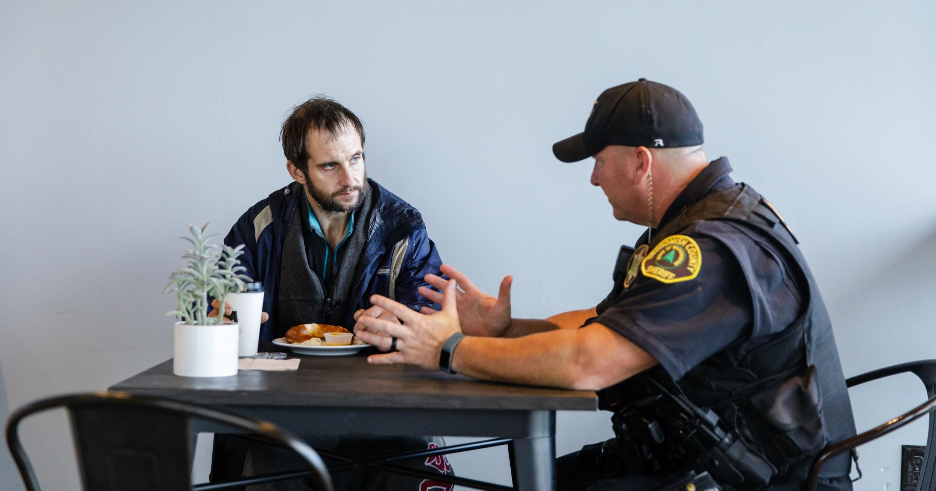
SOME SOLUTIONS COVERED IN THE PODCAST:
- Medication-assisted treatment for opioid addiction
- Overdose reversal drug, Naloxone
- Police-assisted diversion for drug offenders
- Strategies to support families of people with addiction
- Preventing youth addiction
- Treating chronic pain

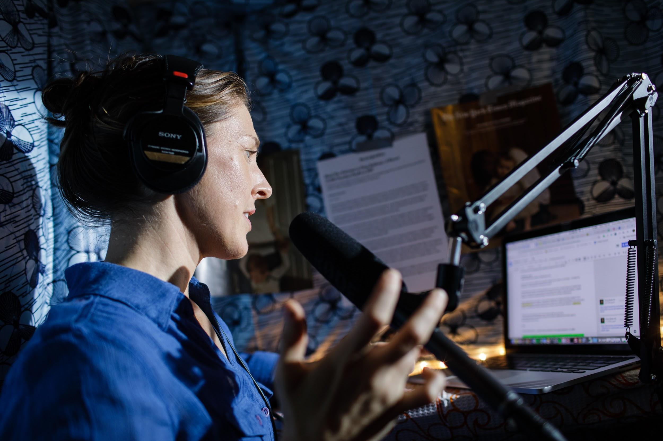
ABOUT THE HOST:
Anna Boiko-Weyrauch grew up in Seattle, Wash. and is an award-winning reporter at Seattle NPR-affiliate station KUOW 94.9 FM. In 2010, she was a producer-in-residence at KEXP and launched a series of stories called, “Why Music Matters” which was nationally syndicated on NPR’s All Things Considered. Finding Fixes is her passion project.

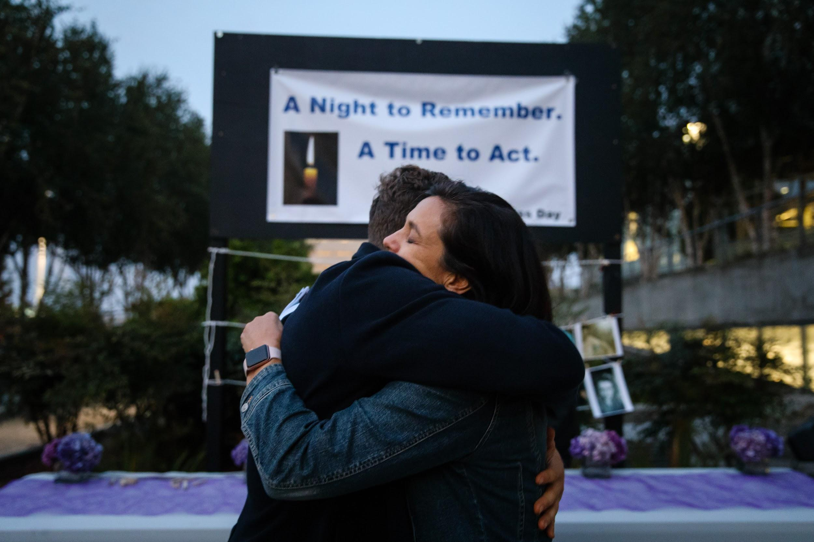
FROM ANNA, WHY I STARTED THIS PODCAST:
“Finding Fixes is different from other reporting because again and again, in the stories that I read, it’s all about, here’s the problem, here’s the ripple effect from the problem, here’s another way that people are suffering, the end. It’s frustrating to read and I feel like something is missing.

Drug addiction is all around us – it’s inescapable. The more that I learn about the opioid epidemic, the more
I see that there are solutions and lots of individuals and communities are working toward those solutions.. And, the more that I talk to those people, the more that I find hope. I’ve found people who are really jazzed up about what they are doing because, it turns out, addiction is a preventable, treatable condition that people can recover from and go on to live very happy, fruitful, and productive lives. But that is a part of the story that isn’t told, and I wanted people to hear more about. That’s become a very big focus of this project – highlighting the voices of people in recovery and focusing on evidence-based solutions.”

CAST & CREW:
Season 1 Co-Host, Editor, and Advisor – Kyle Norris is an award-winning journalist from Michigan who spent 10 years as a host and reporter with Michigan Radio, the state’s largest NPR-affiliate. Known for his conversational, expressive tone, Norris’ stories are driven by deep insights into his characters’ motivations and personal struggles.
Producer – Nicolle Galteland is a journalist and audio producer with a passion for stories about public health. Before returning to her hometown of Seattle, she produced “5% and Falling,” an award-winning podcast from the NYU School of Global Public Health and worked on the podcasts “Aftereffect” and “The Realness at WNYC.”
Editor – Alisa Barba is an award-winning journalist, producer, writer, and editor with 25 years’ experience in both commercial and public broadcasting. Most recently she oversaw a regional reporting team focusing on energy issues in Colorado, Wyoming and North Dakota, known as Inside Energy. Barba also served as Western Bureau Chief for NPR for 12 years.
Producer – Julia Drachman has listened to podcasts for years and recently started making them. With a background in architecture and design, she brings a visual angle to her work in audio. Julia currently lives in her hometown, Seattle, and produces the independent podcast "Design Can Save the World."
Original Music for the podcast was written and performed by Jake Weholt. Additional music from the Free Music Archive by Josh Woodward and Jason Shaw.
Season 2 contributors include journalists Eilís O'Neill, Anne Hoffman, Michelle W. Martin, and Amber Cortes.
Photography by Leah Nash. See more of her work on Instagram or at www.leahnash.com.
Research help from Paul Kiefer. Consulting by Jarett Jackson.

BIBLIOGRAPHY OF BOOKS THAT INFORM THE PODCAST
(ANNA’S FAVORITES IN BOLD):
- Bourgois, P. I., & Schonberg, J. (2009). Righteous dopefiend. Berkeley: University of California Press.
- Buntin, J. (2017). Marlena: A Novel. New York, NY: Henry Holt and Co. (This is a fantastically written novel that gives readers deep insight into the root causes of addiction, from a first-person perspective. -Anna.)
- Courtwright, D. T. (2001). Dark Paradise: A History of Opiate Addiction in America. Cambridge, MA: Harvard University Press.
- Maté, G. (2008). In the realm of hungry ghosts: Close encounters with addiction. Toronto: Knopf Canada.
- Hanson, G. H., Venturelli, P. J., & Fleckenstein, A. E. (2014). Drugs and Society. Edition 12. Burlington, MA: Jones & Bartlett.
- Krosoczka, J. (2018) Hey, Kiddo: How I Lost My Mother, Found My Father, and Dealt with Family Addiction. New York, NY: Graphix. (A graphic novel coming-of-age story. Heartfelt and hard, yet hopeful. My colleague’s 13-year-old son gave it a thumbs up and I do too! - Anna.)
- Mosher, C. J., Akins, S. (2007) Drug and Drug Policy: The Control of Consciousness Alteration. Thousand Oaks, CA: Sage Publications.
- Musto, D. F. (2002). One Hundred Years of Heroin. Westport, CT: Auburn House.
- Quinones, S. (2015). Dreamland: The true tale of America’s opiate epidemic. New York, NY: Bloomsbury Press. (The ULTIMATE account of how the opiate epidemic began and swept the U.S. Find a copy today and read it. -Anna)
- Sheff, D. (2013). Clean: Overcoming addiction and ending America’s greatest tragedy. New York, NY: Houghton Mifflin Harcourt. (Accessible, well-written, backed by evidence yet heartfelt and personal. A great primer to dispel myths and stigma around addiction. -Anna)
- ***Szalavitz, M. (2016). Unbroken Brain: A revolutionary new way of understanding addiction. New York, NY: Picador. (Fantastic. Fantastic. Fantastic. Read it. Comprehensive and groundbreaking. I wish I had read this before anything else. -Anna)
- Temple, J. (2015) American Pain: How a young felon and his ring of doctors unleashed America’s deadliest drug epidemic. Guilford, CT.:Lyons Press. (Exhaustively researched and cinematically written. An inside view into how pill mills could proliferate unchecked and cause so much harm. -Anna)
- van der Kolk, B. A. (2014). The body keeps the score: Brain, mind, and body in the healing of trauma. New York, NY, US: Viking. (I learned so much from this book, I bought a second copy just to lend out to my friends. -Anna)
-END-

